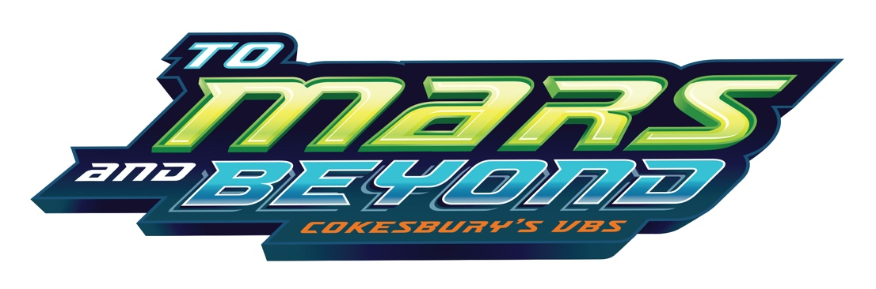

Dear Voyager & Family,

We want to invite you to go on a journey you will never forget. Join us as at Vacation Bible School as we discover God traveling through space. At VBS your child will enjoy an interstellar, interactive, energizing, Bible-based good time. Who knows where God’s power will take us! We’ll leave as earthlings but come home as Voyagers, discovering how to serve God and God’s mission in our lives.

To Mars and Beyond!
JULY 8-12
9:00 AM- 11:30 AM

Register and Learn More
To learn more, go to www.glasfordumc.com/vbs. You can register online or in person, anytime! On our website you will find a ton of information and a sign-up form. In this letter, you’ll find a registration form and a reminder flyer. If you have any questions, please don’t hesitate to call or email us!
SEE YOU AT MISSION CONTROL!

-GUMC Children’s Ministry Team

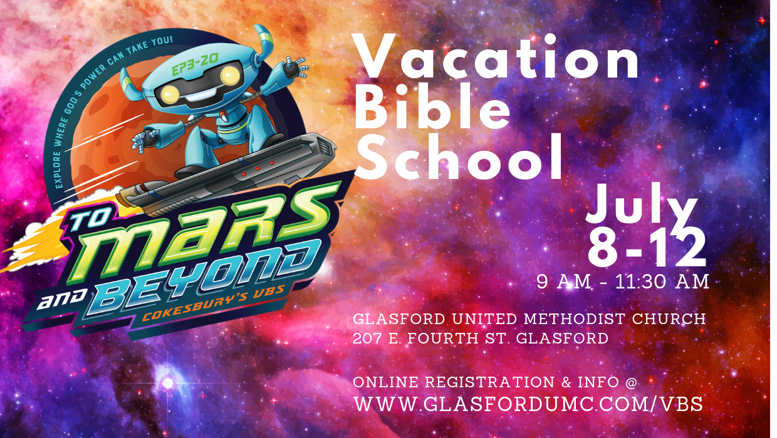

VBS Logistics & Questions:

What is Vacation Bible School?
Vacation Bible School is an outreach program let kids know God loves them, unconditionally. Each day, children will learn lessons from the Bible and learn about who God is with their peers & adults leaders.

Daily Schedule:
- Registration 8:30 am – 9 am
- Opening Assembly: 9 am
- Stations: 9:20 am to 11:20 am
- Closing Assembly: 11:20 am
- Child Pick-up: 11:30 am
- July 12 Friday Celebration: 11:30 am

Who can go to VBS?
Children who are potty trained through 5th and 6th grade can come to VBS.

Is VBS Free
VBS is 100% free!

VBS Mission
The 2019 VBS mission will be collecting daily donations to fund our ‘School Snack-Pack Program’, starting Fall 2019. Your children and family are invited to help fund a ministry that will help support their school peers. To learn more, visit the VBS website.

